**DANISH TO ENGLISH TRANSLATION**

**https://24x7offshoring.com/**

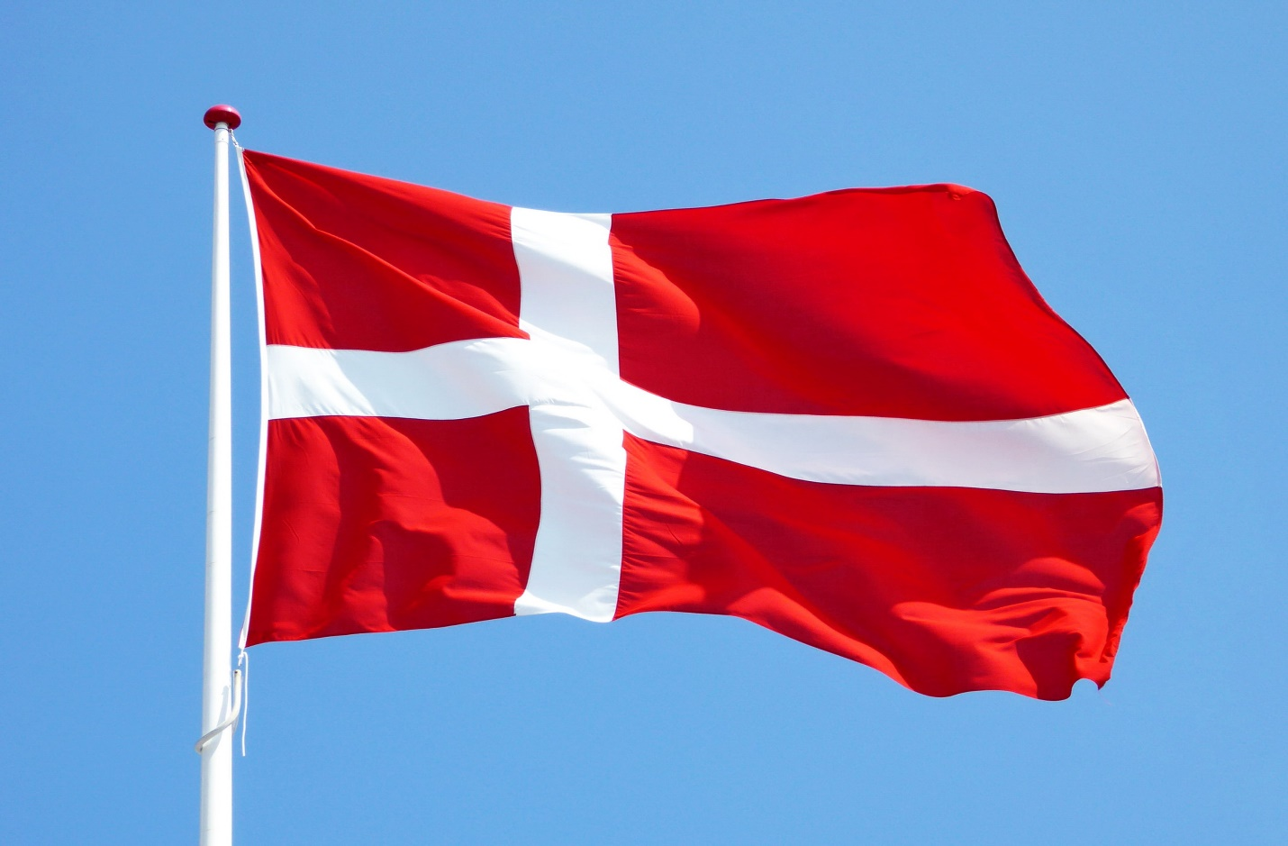[**http://24x7outsourcing.com/**](http://24x7outsourcing.com/)

**Danish interpretation administration**

Danish is a North Germanic language spoken by around 6,000,000 individuals, mainly in Denmark, Greenland and in the area of Southern Schleswig in northern Germany, where it has minority language status.

**Your One-Stop Danish Translation Service**

Denmark has its hands full with numerous global businesses, including dispatching, dairy, data innovation, and worldwide trade.

In the event that you and your business need interpretations for authoritative reports like settlements, forces of lawyer, different licenses, wills, or any specialized or authoritative archive, 24x7offshoring.com has a huge asset of talented interpreters with lawful affirmation in Danish to English interpretation.

Maybe you need Danish interpretation administration for business arrangements, birth or demise authentications, or you need a Danish site meant English - 24x7offshoring.com has the answer for any records requiring proficient Danish interpretation.

There isn't anything too specialized, too perplexing or even too oversimplified that we don't cover as your one-quit driving interpretation administration.

**A Look at Danish Language Translation**

The Danes have played a part in numerous significant Information Technology commitments, for example, C++ script, and the formation of Skype, which have expected Danish to English interpretation. Be that as it may, there are a few things to know about with any Danish report interpretation.

While most Norwegians, Danes and Swedes can comprehend each other, this isn't the situation for English ears. Their dialects sound and appear to be unique to English speakers.

Along these lines, one ought to never utilize a similar Danish report interpretation for Norwegian and Swedish to English interpretations too.

Restricted and territorial varieties, just as word utilization, emphasizes, and different components make the requirement for independent interpretations for each of the three Scandinavian dialects.

Composed Danish is normalized by an exacting standard, yet spoken Danish differs significantly in articulation. Pretty much every island in Denmark has their own tongue, which is hard for significantly different Danes to comprehend. Along these lines, verbally expressed and composed interpretations may shift when English meant.

Scandinavian dialects are frequently erroneously gathered to be one language. Notwithstanding, you would prefer not to expect that since you may have made an interpretation of a Norwegian report to English, that it will serve for an expert Danish interpretation also.

24x7offshoring.com will give you restricted Danish to English interpretation for any piece of Denmark, and for any sort of record.

**Proficient Worldwide Danish**

**Interpretation Service**

24x7offshoring.com gives Danish Translation Service to customers around the world, with an asset of more than 5,000 interpreters.

Regardless of whether you need birth endorsements, IT manuals, authoritative reports, vehicle parts manuals, course books, or some other sort of specialized Danish interpretation, we have an accomplished Danish interpreters with industry explicit experience.

Our two-interpreter technique utilizes one to decipher the archive and one to edit, which guarantees you get mistake free, expedient pivot, and consistently at the most reduced expense conceivable.

For your Danish to English interpretation free statement, essentially utilize our top menu to transfer your content, or interface with our live talk for a free conference.

**DANISH TO ENGLISH TRANSLATION**

**https://24x7offshoring.com/**

**http://24x7outsourcing.com/**